Initial Setup Instructions:
- HTTPS Access to “MCP Client”
- Google Browser -> 127.0.0.1:3080 (username: student@email.local , password: password)
- Chose model as OpenRouter -> Anthropic Claude-3.5-haiku
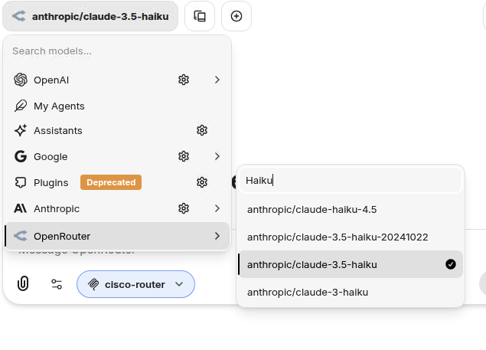
- SSH to “MCP Sever”
- Run the following commands (highlighted):
  - ubuntu@linuxdesktop4:~$ cd ./cisco_mcp/
  - ubuntu@linuxdesktop4: ~/cisco_mcp$ ./run.sh
Starting Cisco MCP Server on http://0.0.0.0:8000...
INFO: Started server process [170569]
INFO: Waiting for application startup.
INFO: Application startup complete.
INFO: Uvicorn running on http://0.0.0.0:8000 (Press CTRL+C to quit)
INFO: 172.18.77.2:40472 - "GET /sse HTTP/1.1" 200 OK
- DO NOT CLOSE THIS WINDOW
- Open a NEW SSH Window
- Run this command:
  - ubuntu@linuxdesktop4:~$ DANGEROUSLY_OMIT_AUTH=true npx @modelcontextprotocol/inspector
Starting MCP inspector...
⚙️ Proxy server listening on 127.0.0.1:6277
⚠️ WARNING: Authentication is disabled. This is not recommended.
🔍 MCP Inspector is up and running at http://127.0.0.1:6274 🚀
- Open the HTTPs Access to MCP Server
- Chrome -> http://127.0.0.1:6274 to open MCP Inspector

